CPE22 – Embedded Systems
Chapter 1: Introduction to Embedded Systems
Embedded Systems: History & Overview
Structure of Embedded Systems
Classification of Embedded Systems
The Life Cycle of Embedded Designs
Design Constraints

1.1 Embedded Systems: History & Overview
Embedded System | - Can be broadly defined as a device that contains tightly coupled hardware and software components to perform a single function, forms part of a larger system, is not intended to be independently programmable by the user, and is expected to work with minimal or no human interaction.  - Two additional characteristics are very common in embedded systems: reactive operation and heavily constrained.  - Most embedded systems interact directly with processes or the environment, making decisions on the fly, based on their inputs. This makes it necessary that the system must be reactive, responding in real-time to process inputs to ensure proper operation.  - These systems operate in constrained environments where memory, computing power, and power supply are limited. Moreover, production requirements, in most cases due to volume, place high-cost constraints on designs
1.1.1 Early Forms of Embedded System | 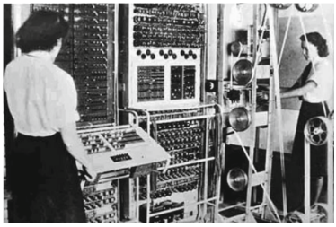  - Colossus Mark I and II computers:  - These electro-mechanical behemoths, designed by the British to break encrypted teleprinter German messages during World War II, were in a certain way similar to what we define as an embedded system.  - Although not based on the concept of a stored-program computer, these machines were able to perform a single function, reprogrammability was very awkward, and once fed with the appropriate inputs, they required minimal human intervention to complete their job.  - Despite their conceptual similarity, these early marvels of computing can hardly be considered as integrative parts of larger system, being therefore a long shot to the forms known today as embedded systems.  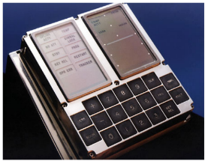  - The AGC incorporated a user interface module based on keys, lamps, and seven segment numeric displays, a hardwired control unit based on 4,100 single three-input RTL NOR gates, 4 KB of magnetic core RAM, and 32 KB of core rope ROM.  - The unit CPU was run by a 2.048MHz primary clock, had four 16-bit central registers and executed eleven instructions. It supported five vectored interrupt sources, including a 20-register timer-counter, a real-time clock module, and even allowed for a low-power standby mode that reduced in over 85% the module’s power consumption, while keeping alive all critical components.  - The system software of the Apollo Guidance Computer was written in AGC assembly language and supported a non-preemptive real-time operating system that could simultaneously run up to eight prioritized jobs.
1.1.2 Birth & Evolution of Modern Embedded Systems | - Gary Boone from Texas Instruments was awarded in 1973 the patent of the first single-chip microprocessor architecture for its 1971 design of the TMS1000. This chip was a 4-bit CPU that incorporated in the same die 1K of ROM and 256 bits of RAM to offer a complete computer functionality in a single-chip, making it the first microcomputer-on-a-chip (a.k.a microcontroller).  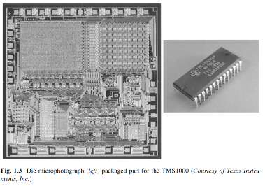  - The TMS1000 was launched in September 1971 as a calculator chip with part number TMS1802NC.  - The i4004, recognized as the first commercial, stand-alone single chip microprocessor, was launched by Intel in November 1971. The chip was developed by a design team led by Federico Faggin at Intel.  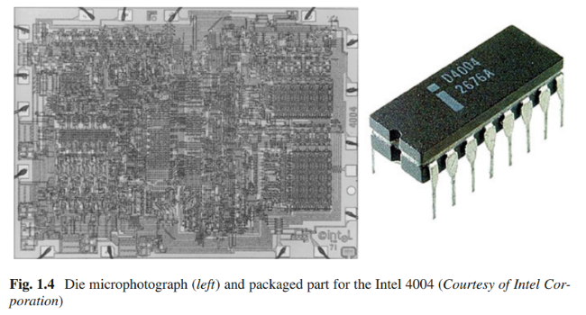  - This design was also a 4-bit CPU intended for use in electronic calculators. The 4004 was able to address 4K of memory, operating at a maximum clock frequency of 740 KHz. Integrating a minimum system around the 4004 required at least three additional chips: a 4001 ROM, a 4002 RAM, and a 4003 I/O interface.  - The third pioneering microprocessor design of that age was a less known project for the US Navy named the Central Air Data Computer (CADC). This system implemented a chipset CPU for the F-14 Tomcat fighter named the MP944.  - The system supported 20-bit operands in a pipelined, parallel multiprocessor architecture designed around 28 chips. Due to the classified nature of this design, public disclosure of its existence was delayed until 1998, although the disclosed documentation indicates it was completed by 1970.  - After these developments, it did not take long for designers to realize the potential of microprocessors and its advantages for implementing embedded applications. Microprocessor designs soon evolved from 4-bit to 8-bit CPUs.  - By the end of the 1970s, the design arena was dominated by 8-bit CPUs and the market for microprocessors-based embedded applications had grown to hundreds of millions of dollars.  - Remarkable parts include the Intel 8080 that eventually evolved into the famous 80 × 86/Pentium series, the Zilog Z-80, Motorola 6800 and MOS 6502. The evolution in CPU sizes continued through the 1980s and 1990s to 16-, 32-, and 64-bit designs, and now-a-days even some specialized CPUs crunching data at 128-bit widths.  - Examples of manufacturers available today include Texas Instruments, Intel, Microchip, Freescale (formerly Motorola), Zilog, Advanced Micro Devices, MIPS Technologies, ARM Limited, and the list goes on and on.
1.1.3 Contemporary Embedded Systems | - Nowadays microprocessor applications have grown in complexity; requiring applications to be broken into several interacting embedded systems. To better illustrate the case, consider the application illustrated in Fig. 1.6, corresponding to a generic multimedia player.  - The system provides audio input/output capabilities, a digital camera, a video processing system, a hard-drive, a user interface (keys, a touch screen, and graphic display), power management and digital communication components.  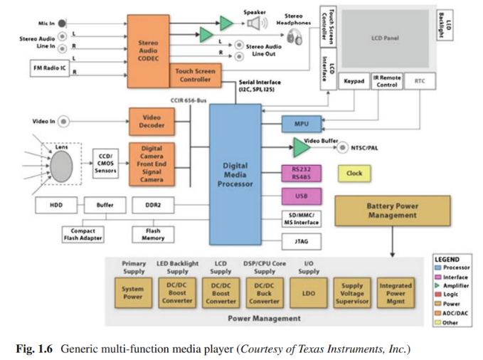  - Each of these features are typically supported by individual embedded systems integrated in the application. Thus, the audio subsystem, the user interface, the storage system, the digital camera front-end, and the media processor and its peripherals are among the systems embedded in this application.
1.2 Structure of Embedded Systems
- Regardless of the function performed by an embedded system, the broadest view of its structure reveals two major, tightly coupled sets of components: a set of hardware components that include a central processing unit, typically in the form of a microcontroller; and a series of software programs, typically included as firmware, that give functionality to the hardware.

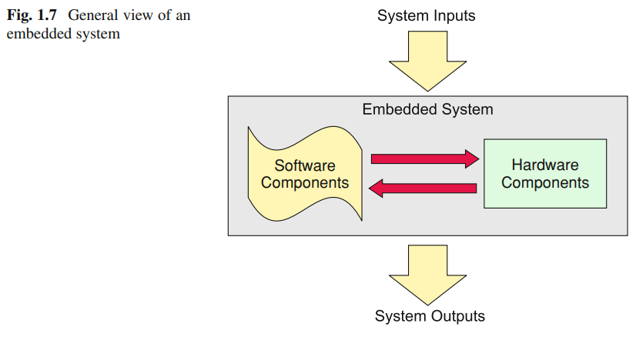
Figure 1.7 depicts this general view, denoting these two major components and their interrelation.
- Typical inputs in an embedded system are process variables and parameters that arrive via sensors and input/output (I/O) ports. The outputs are in the form of control actions on system actuators or processed information for users or other subsystems within the application.

- In some instances, the exchange of input-output information occurs with users via some sort of user interface that might include keys and buttons, sensors, light emitting diodes (LEDs), liquid crystal displays (LCDs), and other types of display devices, depending on the application.

1.2.1 Hardware Components | - When viewed from a general perspective, the hardware components of an embedded system include all the electronics necessary for the system to perform the function it was designed for. Therefore, the specific structure of a particular system could substantially differ from another, based on the application itself.  - Despite these dissimilarities, three core hardware components are essential in an embedded system: The Central Processing Unit (CPU), the system memory, and a set of input-output ports.  - A number of other supporting and I/O devices needed for system functionality might be present, depending on the application. These include:  - Communication Ports  - User Interfaces  - Sensors and electromechanical actuators  - Data converters  - Diagnostics and redundant components  - System support components  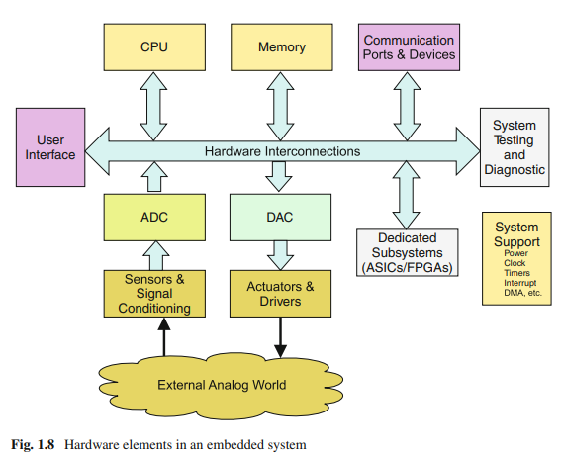  - Other sub-systems (ex. ASIC and FPGA)
1.2.2 Software Components | - The software components of an embedded system include all the programs necessary to give functionality to the system hardware. These programs, frequently referred to as the system firmware, are stored in some sort of non-volatile memory.  - Firmware is not meant to be modifiable by users, although some systems could provide means of performing upgrades. System programs are organized around some form of operating system and application routines.  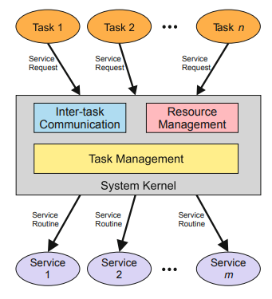  - In some of these cases, designs are developed around Real-Time Operating Systems (RTOS). Figure 1.9 illustrates the structure on an embedded system software.  The major components identified in a system software include:  - System Tasks. The application software in embedded systems is divided into a set of smaller programs called Tasks. Each task handles a distinct action in the system and requires the use of specific System Resources.  - System Kernel. The software component that handles the system resources in an embedded application is called the Kernel. System resources are all those components needed to serve tasks.  - Services. Tasks are served through Service Routines. A service routine is a piece of code that gives functionality to a system resource.  - In some systems, they are referred to as device drivers. Services can be activated by polling or as interrupt service routines (ISR), depending on the system architecture.
1.3 Classification of Embedded Systems
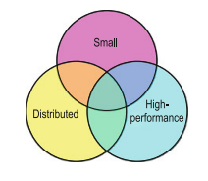
Three defining categories that we can use to classify embedded systems in general: Small, Distributed, and High-performance. Figure 1.10 graphically illustrates the relationships among these classes.
Small Embedded Systems | - Texas Instruments, with the TMS1000 created the microcontroller, which has become the cornerstone component of this type of embedded systems, which is by far, the most common type.  - This class is typically centered around a single microcontroller chip that commands the whole application. These systems are highly integrated, adding only a few analog components, sensors, actuators, and user-interface, as needed.
Distributed Embedded Systems | - The style created by Intel with the 4004 is representative of this type of embedded systems. We refer to the class of embedded systems where the CPU resides in a separate chip while the rest of components like memories, I/O, co-processors, and other special functions are spread across one or several chips in what is typically called the processor chipset.
High-performance Embedded Systems | - The case of the CADC represents the class of highly specialized embedded systems requiring fast computations, robustness, fault tolerance, and high maintainability.  - These systems usually require dedicated ASICS, are typically distributed, might include DSPs and FPGAs as part of the basic hardware.  - These are the type of embedded systems used in military and aerospace applications, such as flight controllers, missile guidance systems, and space craft navigation systems.
1.4 The Life Cycle of Embedded Systems
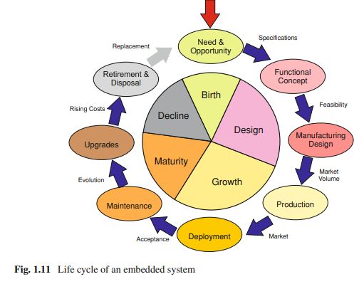
Five stages can be identified in the cycle: Conception or Birth, Design, Growth, Maturity, and Decline. Figure 1.11 illustrates the sequence of these stages, and the critical phases that compose each stage.

- An embedded design is first conceived by the identification of a need to solve a particular problem, or the opportunity to apply embedded technology to an old problem.
- In the design stage, the system goes first through a phase of functional design, where proof-of-concept prototypes are developed.
- The growth stage initiates with the production of the system to supply an estimated market demand.
- In the maturity stage, the product is kept functional and up to date. This involves providing technical support, periodic maintenance, and servicing.
- In the decline stage, system components become obsolete and difficult to obtain, driving the cost of maintenance, service, and upgrades to levels that approach or exceed those of replacing the whole system at once.

1.5 Design Constraints
A vast majority of embedded systems applications end up in the heart of mass-produced electronic applications. Home appliances such as microwave ovens, toys, and dishwasher machines, automobile systems such as anti-lock brakes and airbag deployment mechanisms, and personal devices such as cellular phones and media players are only a few representative examples.

The most important constraints in the list include:

Functionality | The system ability to perform the function it was designed for.
Cost | The amount of resources needed to conceive, design, produce, maintain, and discard an embedded system.
Performance | The system ability to perform its function on time.
Size | Physical space taken by a system solution.
Power & Energy | Energy required by a system to perform its function.
Time to Market | The time it takes from system conception to deployment.
Maintainability | System ability to be kept functional for the longest of its mature life.

Aside from functionality, the relevance of the rest of the constraints in the list changes from one system to another. In many cases, multiple constraints must be satisfied, even when these can be conflicting, leading to design tradeoffs.

1.5.1 Functionality | - Every embedded system design is expected to have a functionality that solves the problem it was designed for. More than a constraint, this is a design requirement.  - The task of verifying the functionality of the hardware and software components of an embedded system falls in the category of NP-hard problems (problems for which a proposed solution can be verified quickly). The most commonly used methods include the following:  Behavioral Simulation The system is described by a behavioral model and suitable tools are used to simulate the model.  Logic & Circuit-level Simulation These methods apply to dedicated hardware components of the system.  Processor Simulation This method uses programs written to simulate the functionality of software developed for a target processor or microcontroller on a personal computer or workstation.  JTAG Debuggers JTAG is an acronym for Joint Test Action Group, the name given to the Standard Test Access Port and Boundary Scan Architecture for test access ports in digital circuits.  In-Circuit Simulation Hardware Emulation is the process of imitating the behavior of a hardware component with another one for debugging purposes.  Other Verification Tools Other tools used for embedded system verification include Background Mode Emulators (BMEs) and ROM Monitors.
1.5.2 Cost | - Developing an embedded system from scratch is a costly process. In a broad sense, the total cost C_{T} of producing a certain volume V of units an embedded system can be obtained as, $CT=NRE+(RP*V)$ where NRE represent the Non-recurring Engineering (NRE) costs for that product, (RP) represents the Variable or Recurrent Production costs , and the production volume V is the number of marketed units.  Example:  Apple reported selling 125,000 iPods in the first quarter 2002 with the given of NRE set to $10M and production cost of each unit is $120, compute for the total cost.  Given: NRE = 10M, RP = 120, V = 125,000 Find: C_{T}  Solution:  $CT=NRE+(RP*V)$  $$CT=10M+\left(120*125,000\right)$$  $$CT=10M+15M$$  $$CT=\$25M$$  What if we want to know the Unit Cost of iPod of the said batch?  $$U_{c}=\frac{C_{t}}{V}=\frac{NRE}{V}+RP$$  Solution:  $U_{c}=\frac{NRE}{V}+RP$  $U_{c}=\frac{10M}{125,000}+120$  $U_{c}=80+120$  $$U_{c}=\$200$$
1.5.3 Performance | - Performance in embedded systems usually refers to the system ability to perform its function on time. Therefore, a measure of the number of operations per unit time will somehow always be involved.  - Performance in embedded systems depends on many factors, some due to hardware components, some other due to software components.
Hardware related factors include:
Clock Frequency | the speed at which the master system clock ticks to advance time in the system.
Processor Architecture | has a deep impact in the system performance. The use of multiple execution units, pipelining, caches, style (CISC2 versus RISC3 ) buses, among other architectural differences affect the time the system takes to complete a task.
Handshaking Protocols | i.e. the way transactions begin and end with peripheral devices and how frequently they need to occur will take their toll in the time the system takes to complete a task.
Low-Power Mode | in hardware components also affect performance. When a component is sent to a low-power or sleep mode, either by gating its clock, its power lines, or some other mechanism, waking the device up consumes clock cycles, ultimately affecting its response time.
Software factors - affecting system performance include:
Algorithm Complexity | Although algorithm complexity traditionally refers to the way the number of steps(or resources) needed to complete a task scales as the algorithm input grows, it also provides a measure of how many steps it would take a program to complete a task.
Task Scheduling | determines the order in which tasks are assigned service priorities in a multitasking environment.
Intertask Communication | deals with the mechanisms used to exchange information and share system resources between tasks.
Level of Parallelism | refers to the usage given by the software to system resources that accept simultaneous usage.
1.5.4 Power & Energy | - Power in embedded systems has become a critical constraint, not only in portable, battery-operated systems, but for every system design. The average power dissipation of an embedded design defines the rate at which the system consumes energy.  - In battery powered applications, this determines how long it takes to deplete the capacity of its batteries. But aside from battery life, power affects many other issues in embedded systems design. Some of the most representative issues include:  System Reliability In digital electronic systems, which operate at a relatively fixed voltage level, power translates into current intensities circulating through the different system traces and components.  Cooling Requirements A large power consumption leads to large levels of heat dissipation. Heat needs to be removed from the embedded electronics to avoid the failures induced by high temperature operation.  Power Supply Design All embedded systems need a source of energy. Portable systems rely on batteries. Stationary systems need power supplies.  System Size, Weight, & Form The mechanical design characteristics are affected by the minimum admissible separation between components to limit heat density and reduce the risk of heat induced failures.  Environmental Impact The number of embedded systems around us continues to grow at accelerated rates. Estimates by the Consumer Electronics Association (CEA) show that nowadays an average individual uses about sixty embedded systems per day.  Hardware Design Utilizing processors and hardware components specifically designed to minimize power consumption.  Software Design The way in which software is designed has a significant impact on the system power consumption.  Power Management Techniques Power management combines software strategies for power reduction with the hardware capabilities of the system to reduce the amount of energy needed to complete a task.
1.5.5 Time to Market | - Time to market (TTM) is the time it takes from the conception of an embedded system until it is launched into the market. TTM becomes a critical constraint for systems having narrow market windows.
1.5.6 Reliability & Maintainability | - Maintainability in embedded systems can be defined as a property that allows the system to be acted upon, to guarantee a reliable operation throughout the end of its useful life  - From a broad perspective, maintainability needs to provide the system with means for executing four basic types of actions:  Corrective Actions that allow to fix faults discovered in the system.  Adaptive Actions which enable the introduction of functional modifications that keep the system operating in a changing environment.  Perfective Actions to allow for adding enhancements to the system functionally attending to new regulations or requirements.  Preventive Actions that anticipate and prevent conditions that could compromise the system functionality.  Issues in Hardware Maintainability:  Cost Overhead in the system NRE related to the design and validation of maintenance and testing structures.  Impact on the time-to-market caused by additional development time required for the inclusion of maintainability features.  Increase in Recurrent Costs caused by the additional hardware components needed in the system to support testing and maintenance.  Other factors affecting hardware maintainability in deployed systems include problems of component obsolescence, accessibility to embedded hardware components, and availability of appropriate documentation to guide changes and repairs.  Issues in Software Maintainability:  - Unstable requirements  - Technology changes  - Location errors  - Impact of change  - Need for trained personnel  - Inadequate documentation  - Development versus application environment  - Hardware constraints  - Testing process  Other Problems: These include software decay, complexity in upgrading processes, physical accessibility, and integration issues among others.

Chapter 2: Embedded Software Techniques
Embedded Firmware Design & Development
Embedded firmware Development Languages/Options

Embedded Firmware | - The control algorithm (Program instructions) and or the configuration settings that an embedded system developer dumps into the code (Program) memory of the embedded system.  - It is an un-avoidable part of an embedded system.  The embedded firmware can be developed in various methods like:  - Write the program in high level languages like Embedded C/C++ using an Integrated Development Environment (The IDE will contain an editor, compiler, linker, debugger, simulator etc. IDEs are different for different family of processors/controllers).  - Write the program in Assembly Language using the Instructions Supported by your application‘s target processor/controller.
Embedded Firmware Design & Development | - The embedded firmware is responsible for controlling the various peripherals of the embedded hardware and generating response in accordance with the functional requirements of the product.  - The embedded firmware is the master brain of the embedded system.  - The embedded firmware imparts intelligence to an Embedded system.  - The product starts functioning properly once the intelligence imparted to the product by embedding the firmware in the hardware.  - The product will continue serving the assigned task till hardware breakdown occurs or a corruption in embedded firmware.  - In case of hardware breakdown , the damaged component may need to be replaced and for firmware corruptions the firmware should be re-loaded, to bring back the embedded product to the normal functioning.  - The embedded firmware is usually stored in a permanent memory (ROM) and it is non alterable by end users.  - Designing Embedded firmware requires understanding of the particular embedded product hardware, like various component interfacing, memory map details, I/O port details, configuration and register details of various hardware chips used and some programming language (either low level Assembly Language or High level language like C/C++ or a combination of the two)  - The embedded firmware development process starts with the conversion of the firmware requirements into a program model using various modeling tools.  - The firmware design approaches for embedded product is purely dependent on the complexity of the functions to be performed and speed of operation required. There exist two basic approaches for the design and implementation of embedded firmware, namely:  The Super Loop Approach - The Super loop based firmware development approach is Suitable for applications that are not time critical and where the response time is not so important. - It is very similar to a conventional procedural programming where the code is executed task by task. The tasks are executed in a never-ending loop. The task listed on top on the program code is executed first and the tasks just below the top are executed after completing the first task. Pros: - Doesn‘t require an Operating System for task scheduling and monitoring and free from OS related overheads - Simple and straight forward design - Reduced memory footprint Cons: - Non Real time in execution behavior (As the number of tasks increases the frequency at which a task gets CPU time for execution also increases) - Any issues in any task execution may affect the functioning of the product. Enhancement: - Combine Super loop based technique with interrupts - Execute the tasks (like keyboard handling) which require Real time attention as Interrupt Service routines.  Embedded OS based Approach - The embedded device contains an Embedded Operating System which can be one of: - A Real Time Operating System (RTOS) - A Customized General Purpose Operating System (CGPOS) - The Embedded OS is responsible for scheduling the execution of user tasks and the allocation of system resources among multiple tasks - It involves a lot of OS related overheads apart from managing and executing user defined tasks - Microsoft® Windows OS Embedded is an example of GPOS for embedded devices - Point of Sale (PoS) terminals, Gaming Stations, Tablet PCs etc are examples of embedded devices running on embedded GPOSs. - Windows CE, Windows Mobile, QNX, VxWorks, ThreadX, MicroC/OS-II, Embedded Linux, Symbian etc. are examples of RTOSs employed in Embedded Product development - Mobile Phones, PDAs, Flight Control Systems etc. are examples of embedded devices that runs on RTOSs
Embedded firmware Development Languages | - Assembly Language  - High Level Language  - Subset of C (Embedded C)  - Subset of C++ (Embedded C++)  - Any other high level language with supported Cross-compiler  - Mix of Assembly & High level Language  - Mixing High Level Language (Like C) with Assembly Code  - Mixing Assembly code with High Level Language (Like C)  - Inline Assembly
Assembly Language | - Assembly Language is the human readable notation of machine language  - Machine language is a processor understandable language  - Machine language is a binary representation and it consists of 1s and 0s  - Assembly language and machine languages are processor or controller dependent  - Assembly language programming is the process of writing processor specific machine code in mnemonic form, converting the mnemonics into actual processor instructions (machine language) and associated data using an assembler  - The general format of an assembly language instruction is an Opcode followed by Operands.  - The Opcode tells the processor/controller what to do and the Operands provide the data and information required to perform the action specified by the opcode.  - It is not necessary that all opcode should have Operands following them. Some of the Opcode implicitly contains the operand and in such situation no operand is required. The operand may be a single operand, dual operand or more.  Advantages:  - Efficient Code Memory & Data Memory Usage (Memory Optimization): The developer is well aware of the target processor architecture and memory organization, so optimized code can be written for performing operations.  - High Performance: Optimized code not only improves the code memory usage but also improves the total system performance.  - Low level Hardware Access: Most of the code for low level programming like accessing external device specific registers from OS kernel, device drivers, and low-level interrupt routines, etc. are making use of direct assembly coding.  - Code Reverse Engineering: It is the process of understanding the technology behind a product by extracting the information from the finished product.  Drawbacks:  - High Development time: The developer takes lot of time to study about architecture ,memory organization, addressing modes and instruction set of target processor/controller.  - Developer dependency: There is no common written rule for developing assembly language based applications.  - Non-portable: Target applications written in assembly instructions are valid only for that particular family of processors and cannot be re-used for another target processors/controllers.
High Level Language (C/C++) | - The embedded firmware is written in any high level language like C, C++  - A software utility called cross-compiler converts the high level language to target processor specific machine code  - The cross-compilation of each module generates a corresponding object file. The object file does not contain the absolute address of where the generated code needs to be placed (a re-locatable code) on the program memory.  - The software program called linker/locater is responsible for assigning absolute address to object files during the linking process  - The Absolute object file created from the object files corresponding to different source code modules contain information about the address where each instruction needs to be placed in code memory  - A software utility called Object to Hex file converter translates the absolute object file to corresponding hex file (binary file)  Advantages:  - Reduced Development time: Developer requires less or little knowledge on internal hardware details and architecture of the target processor/Controller.  - Developer independency: The syntax used by most of the high level languages are universal and a program written high level can easily understand by a second person knowing the syntax of the language  - Portability: An Application written in high level language for particular target processor/controller can be easily be converted to another target processor/controller specific application with little or less effort.  Drawbacks:  - The cross compilers may not be efficient in generating the optimized target processor specific instructions.  - Target images created by such compilers may be messy and non-optimized in terms of performance as well as code size.  - The investment required for high level language based development tools (IDE) is high compared to Assembly Language based firmware development tools.
Mixing of Assembly Language with High Level Language: | - Embedded firmware development may require the mixing of Assembly Language with high level language or vice versa.  - Interrupt handling and Source code is already available in high level language/Assembly Language etc. are examples.  - High Level language and low level language can be mixed in three different ways:  - Mixing Assembly Language with High level language like C  - Mixing High level language like C with Assembly Language  - In line Assembly  - The passing of parameters and return values between the high level and low level language is cross-compiler specific.
Assembly Language with C | - Assembly routines are mixed with C in situations where the entire program is written in C and the cross compiler in use do not have built in support for implementing certain features like ISR (Interrupt Service Routine).  - If the programmer wants to take advantage of the speed and optimized code offered by the machine code generated by hand written assembly rather than cross compiler generated machine code.  - For accessing certain low level hardware ,the timing specifications may be very critical and cross compiler generated machine code may not be able to offer the required time specifications accurately.  - Writing the hardware/peripheral access routine in processor/controller specific assembly language and invoking it from C is the most advised method. Mixing C and assembly is little complicated.  - The programmer must be aware of how to pass parameters from the C routine to assembly and values returned from assembly routine to C and how Assembly routine is invoked from the C code.
C with Assembly Language: | - The source code is already available in assembly language and routine written in a high level language needs to be included to the existing code.  - The entire source code is planned in Assembly code for various reasons like optimized code, optimal performance, efficient code memory utilization and proven expertise in handling the assembly.  - The functions written in C use parameter passing to the function and returns values to the calling functions.  - The programmer must be aware of how parameters are passed to the function and how values returned from the function and how function is invoked from the assembly language environment.
Inline Assembly | - Inline assembly is another technique for inserting the target processor/controller specific assembly instructions at any location of source code written in high level language C.  - Inline Assembly avoids the delay in calling an assembly routine from a C code.  - Special keywords are used to indicate the start and end of Assembly instructions.

